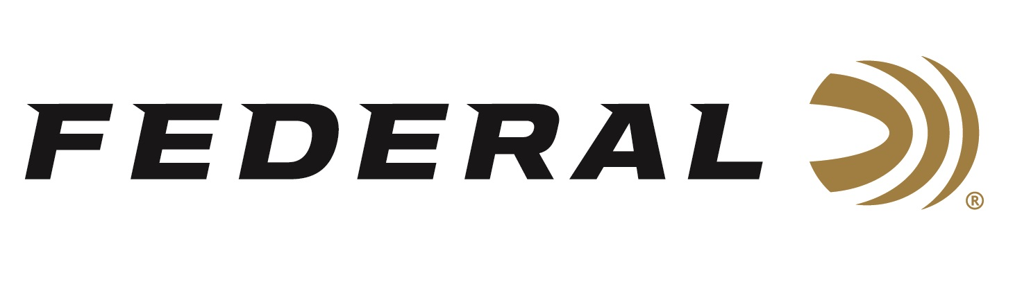

FOR IMMEDIATE RELEASE

Gold Medalist Amber English Joins Team Federal

ANOKA, Minnesota – January 21, 2022 – Federal Ammunition is proud to announce Olympic gold medalist Amber English has joined Team Federal. The record setting English won the Women’s Skeet competition at the Tokyo Olympics this past summer while representing the United States of America.

“We are extremely happy to have Amber join our Federal Team," stated Jason Nash, Federal’s VP of Marketing. "It was exciting to watch her perform at the highest level in Tokyo, and we anticipate that same level of performance as she joins our roster of world class competitors.”

“I cannot believe I can live out my dream and represent the best ammo company in the world,” stated Amber English, who recently concluded her service with the U.S. Army Marksmanship Unit and World Class Athlete Program. “The Army provided me with the exact tools I needed to win.”

English reached the pinnacle of her competitive career with a record setting performance shooting a 56 in the Women’s Skeet finals and became only the second woman in U.S. history to medal in the discipline.

“My favorite memory of my gold medal performance was making myself stick to what was going to make me complete the ‘task at hand’ until every target broke,” claimed English. “I knew on the last station I had to hit two of the four to tie, and if I hit one more I won. Making myself hit that last target was something I'll never forget. When the match was over, I couldn't believe we were actually done!”

English says she is excited to continue to compete using Federal’s Gold Medal Papers, her ammunition of choice, and has current plans to make up for lost time in the outdoors.

For more information on all products and online services from Federal or to shop online, visit www.federalpremium.com.

Press Release Contact: JJ Reich
Senior Manager – Press Relations
E-mail: VistaPressroom@VistaOutdoor.com
About Federal Ammunition
Federal, headquartered in Anoka, MN, is a brand of Vista Outdoor Inc., an outdoor sports and recreation company. From humble beginnings nestled among the lakes and woods of Minnesota, Federal Ammunition has evolved into one of the world's largest producers of sporting ammunition. Beginning in 1922, founding president, Charles L. Horn, paved the way for our success. Today, Federal carries on Horn's vision for quality products and service with the next generation of outdoorsmen and women. We maintain our position as experts in the science of ammunition production. Every day we manufacture products to enhance our customers' shooting experience while partnering with the conservation organizations that protect and support our outdoor heritage. We offer thousands of options in our Federal Premium and Federal® lines-it's what makes us the most complete ammunition company in the business and provides our customers with a choice no matter their pursuit.

